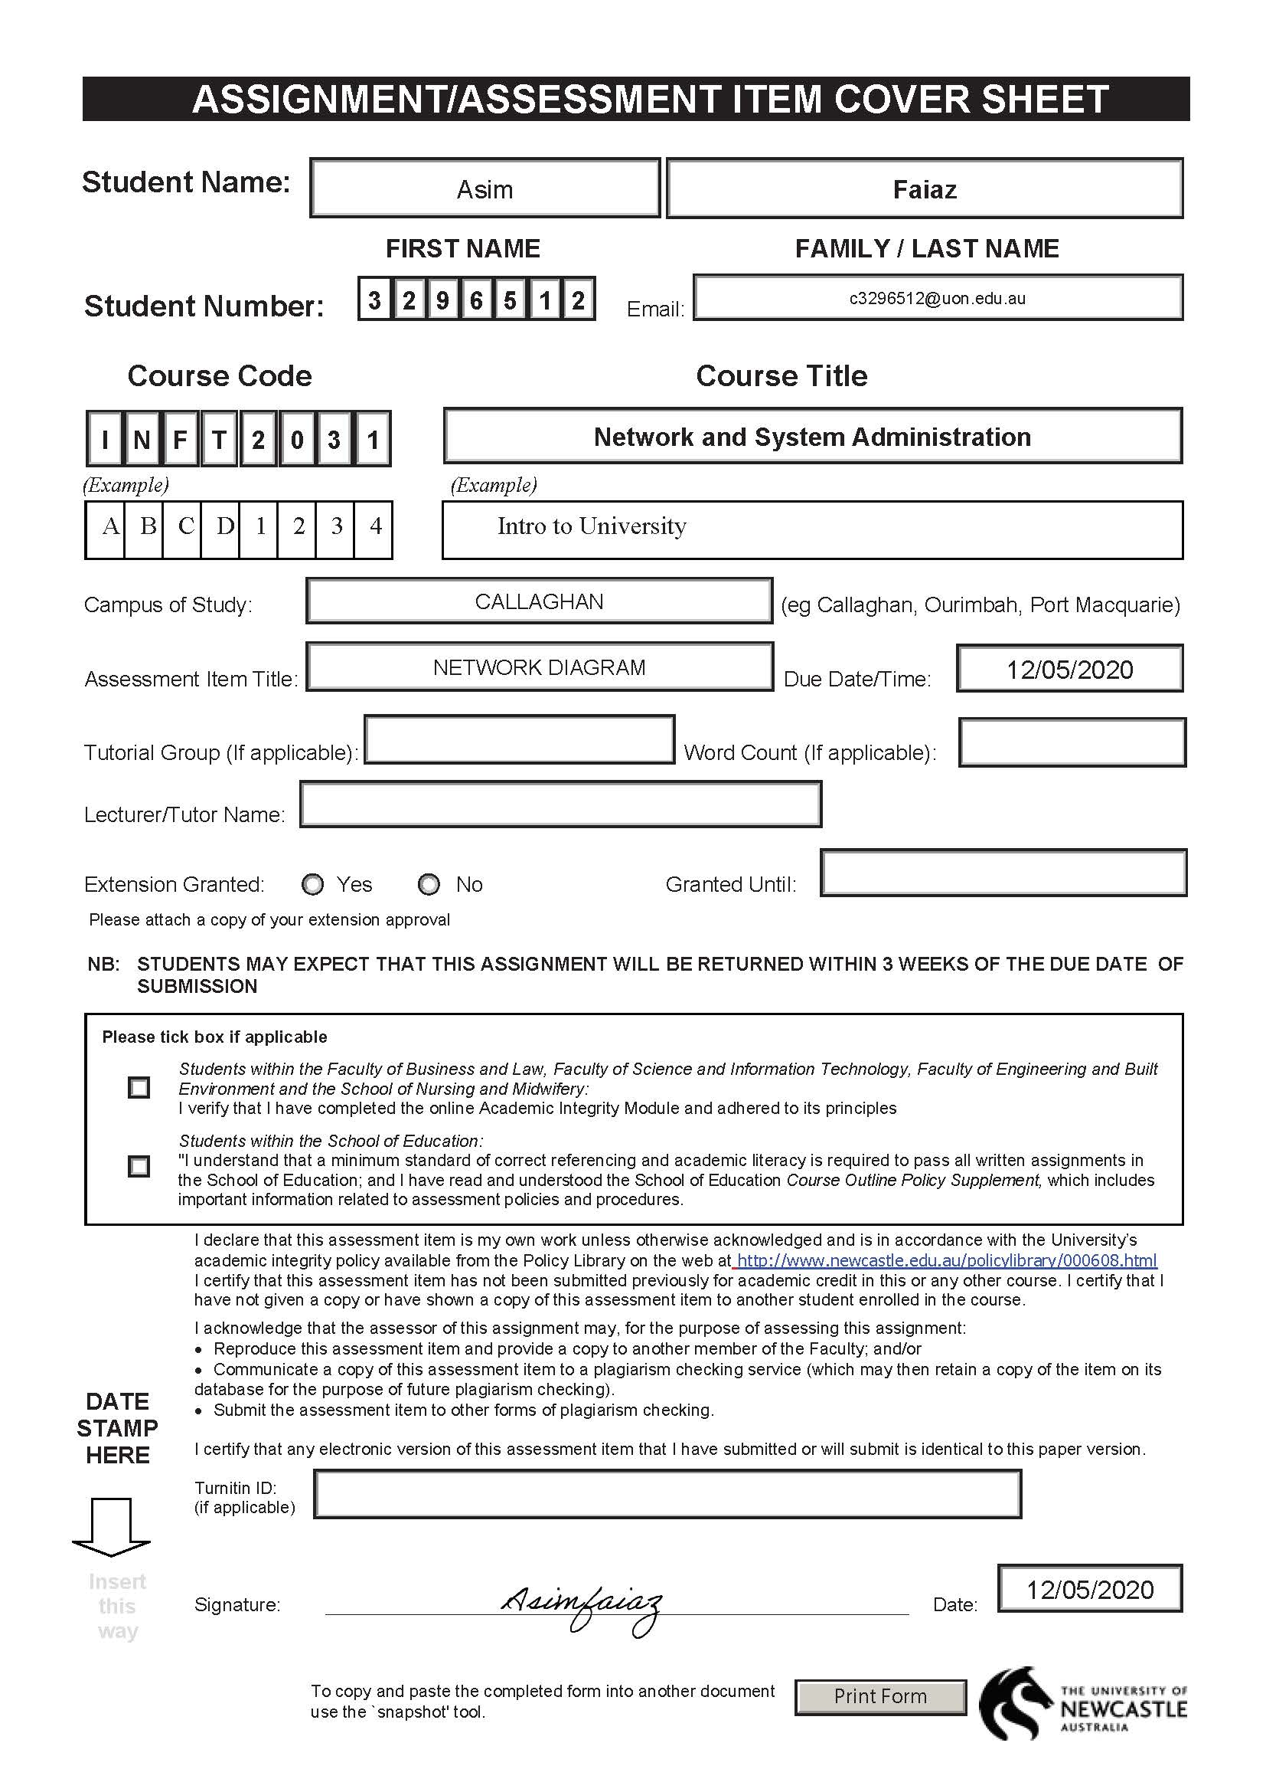

INFT2031 Network and System Administration

Assignment 1

ABC Consultants Pte Ltd

Network diagram with needed resources for ABC-Consultants network and set up a proper Legend. Made this diagram by using IPv4 addressing scheme.

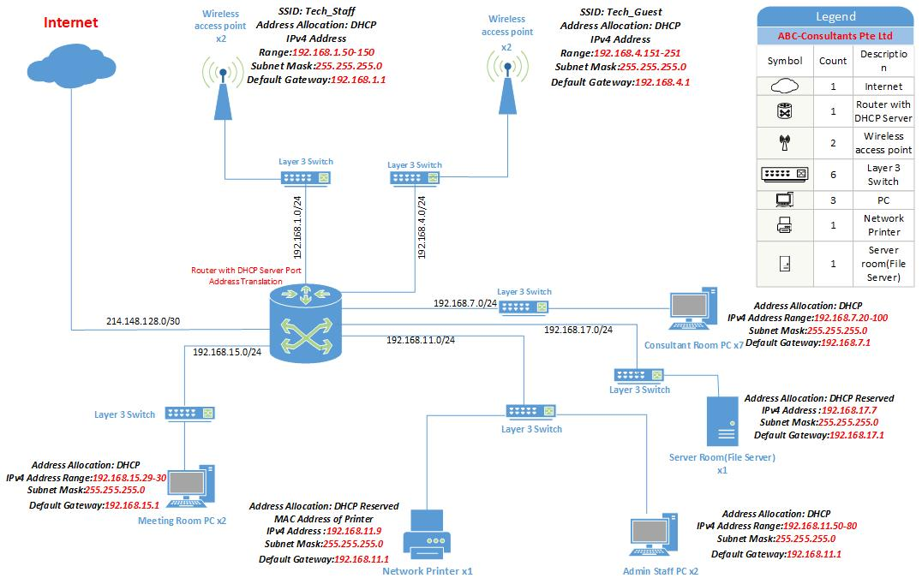

Budget for the Hardware Resources

I did my researched-on Internet and tried to find out the possible costing.

|  |  |  |  |
| --- | --- | --- | --- |
| Product | Description | Cost Per Item | Total |
| Router | CISCO1921-K9 | $965 | $965 |
| Layer 3 Switch x6 | Alloy AS5026-P 26 Port | $995 | $5970 |
| Wireless access point x4 | Netgear EX7700 | $269 | $1076 |
| Total Cost - $8011 | |

Estimated Budget is possibly $ 8011

References:

Router: <https://www.iptrading.com.au/product/cisco/routers/cisco-1900-series/1921-series-integrated-services-routers/19018/CISCO1921-K9?gclid=EAIaIQobChMIqL_U-qWt6QIVSw4rCh28ZAsfEAQYASABEgID0_D_BwE>

Layer 3 Switch: <https://www.mwave.com.au/product/alloy-as5026p-26-port-layer-3-lite-managed-poe-switch-ac18742>

Wireless access point: <https://www.binglee.com.au/netgear-ex7700-nighthawk-x6-tri-band-wifi-mesh-extender?utm_source=getprice&utm_medium=cpc>

Network diagram explanation:

This is the most possible network diagram design for ABC Consultant Pte Ltd. The use of multiple layer 3 switch in this diagram to allow network divide into different subnets, routing easier and faster. The reason of using multiple switch is that just in case if the system breaks down it will not stop the entire system like the core switches do. Wireless access point used to make the router secure. All done by using VLan software. The server room and Printer has given a reserved IP address to accessed by everyone from different devices. All the IP addresses given by DHCP serve as you can see I’ve used the block of private addresses.